Math 3: 4.5 Graphing Polynomial Functions

Solve for x.
- ${25x}^{2}-81=0$ | - $6x^{2}+54x+108=0$ | - $x^{2}-3x-40=0$
- $2x^{3}+x^{2}-18x-9=0$ | - $2x^{3}-3x^{2}-35x=0$ | - $3x^{3}-5x^{2}-12x+20=0$

Factor each polynomial.
- $8x^{3}-343$ | - $x^{4}+11x^{2}+30$
- $x^{2}+81$ | - $x^{4}-6x^{2}-27$

Without graphing, tell the end behavior of the function.
- $f\left(x\right)=\frac{1}{7}x^{3}+4x^{2}-\frac{2}{7}x+5$  as x → + ∞, f(x) → ______  as x → − ∞, f(x) → ______ | - $f\left(x\right)=-3x^{4}+7$  as x → + ∞, f(x) → ______  as x → − ∞, f(x) → ______
- $f\left(x\right)=-3(x+5)(x-6)(x+10)$  as x → + ∞, f(x) → ______  as x → − ∞, f(x) → ______ | - $f\left(x\right)=\left(x+3\right)\left(x+1\right){\left(x-7\right)}^{2}$  as x → − ∞, f(x) → ______  as x → + ∞, f(x) → ______

Tell each zero of the function. Include multiplicities if applicable.
- $f\left(x\right)=-\frac{1}{2}\left(x+3\right){\left(x-2\right)}^{2}$ | - $g\left(x\right)=2x\left(x-4\right)\left(x-8\right)\left(x+2\right)$ | - $h\left(x\right)={\left(x-7\right)}^{4}{\left(x+5\right)}^{2}$

Write an equation in standard form for the cubic function.
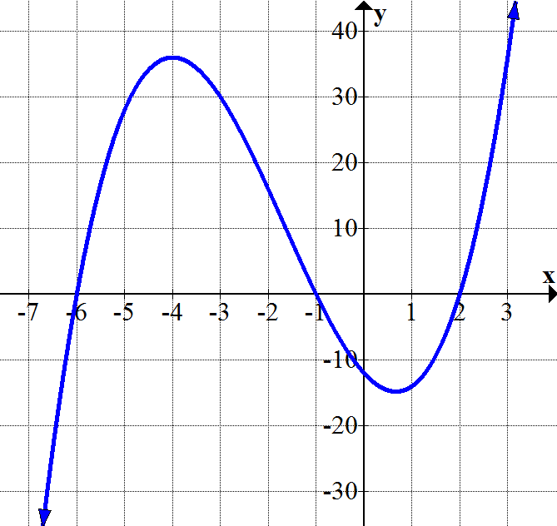  (0, -12) | - x-intercepts: 7, 2, -5; y-intercept: 10

The graph a quartic polynomial equation $f(x)$ is shown. Graph the transformations requested.
$$f(x)$$  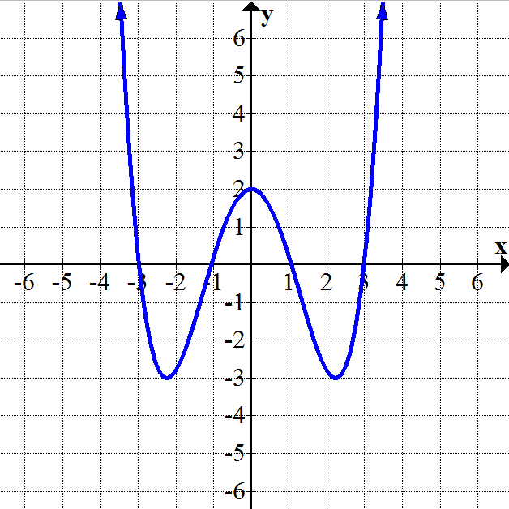 | - $f(x)-3$  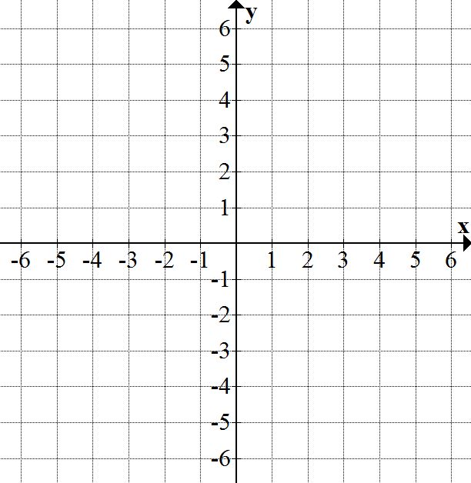 | - $f(x-3)$
State the number of complex roots and the number of real roots for each function shown.
- 4th degree polynomial: 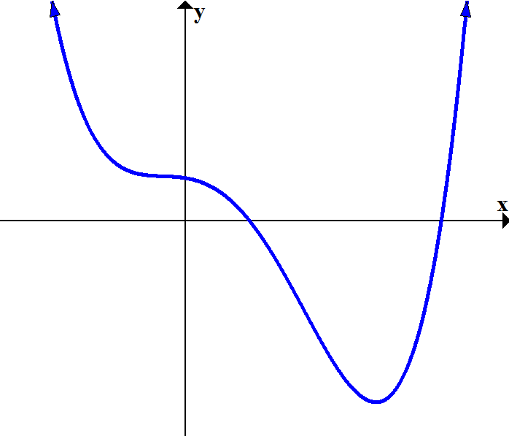  # Complex Roots: ____  # Real Roots: ____  # Non-Real Roots: ____ | - 3rd degree polynomial:  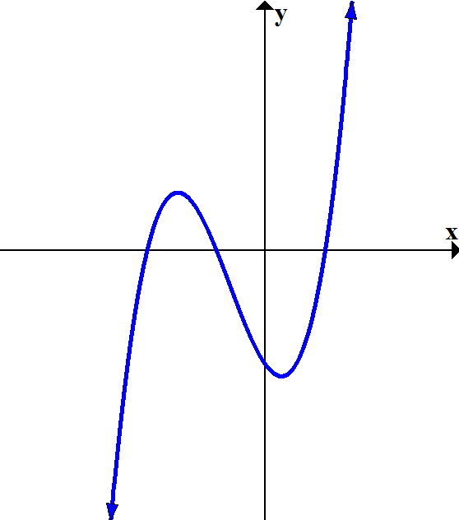  # Complex Roots: ____  # Real Roots: ____  # Non-Real Roots: ____ | - 5th degree polynomial:  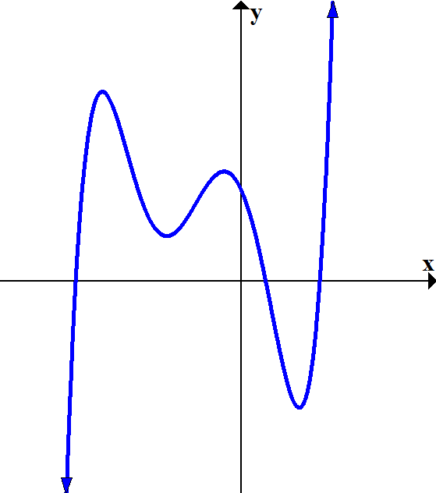  # Complex Roots: ____  # Real Roots: ____  # Non-Real Roots: ____ | - 3rd degree polynomial:  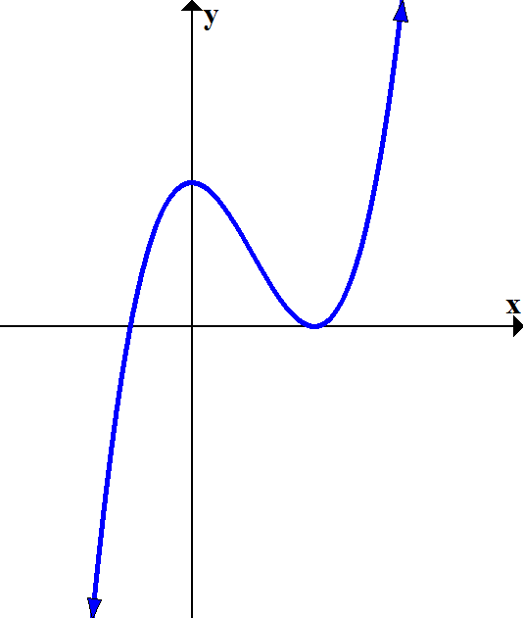  # Complex Roots: ____  # Real Roots: ____  # Non-Real Roots: ____
Graph each function. Be sure to indicate the value of the y-intercept on the graph. (use end behavior, zeros, multiplicities…)
- $f(x)=(x+3)(x-1)(x-2)$  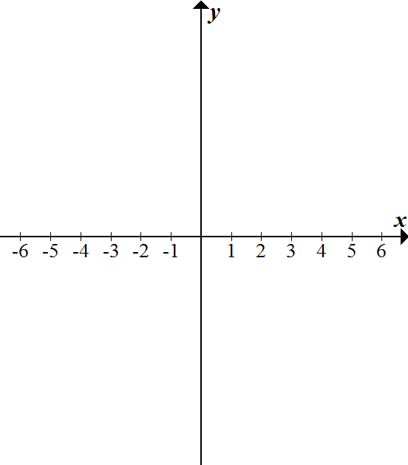 | - $g(x)=(x+4)(x-3)(x-1)(x+1)$ | - $h\left(x\right)=-\frac{1}{4}\left(x+3\right){\left(x-2\right)}^{2}$
- $j\left(x\right)=2x(x+5)(x-5)$  Select Answers: 1) $x=±9/5$; 2) $x=-3, -6$; 3) $x=8, -5$; 4) $x=±3, -1/2$; 5) $x=5, -7/2$; 6) $x=±2, 5/3$;  7) $(2x-7)(4x^{2}+14x+49)$; 8)$(x^{2}+6)(x^{2}+5)$; 9) $(x+9i)(x-9i)$; 10) $(x+3)(x-3)(x^{2}+3)$; 11) +∞, -∞; 12) -∞, -∞;  13) -∞, +∞; 14) +∞, +∞; 15) -3, 2 (mult. 2); 16) 0, 4, 8, -2; 17) 7 (mult 4), -5 (mult 2); 18)$f\left(x\right)=x^{3}+5x^{2}-8x-12$;  19)$f\left(x\right)=\frac{1}{7}x^{3}-\frac{4}{7}x^{2}-\frac{31}{7}x+10$; 22) cmplx:4, real: 2, non-real: 2; 23) cmplx:3, real: 3, non-real: 0; 24) cmplx: 5, real: 3, nonreal 2; 25) cmplx:3, real: 3, non-real: 0; | - $k\left(x\right)={\left(x-3\right)}^{3}$ | - $r\left(x\right)=-{\left(x+5\right)}^{2}\left(x-2\right)(x+2)$

