Math 3: 4.6 Review
For each function, state the information requested.
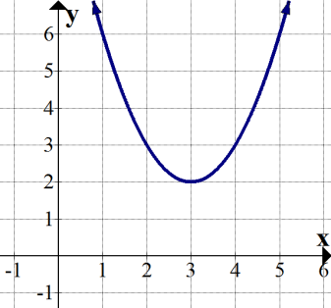  Domain:  Range: | 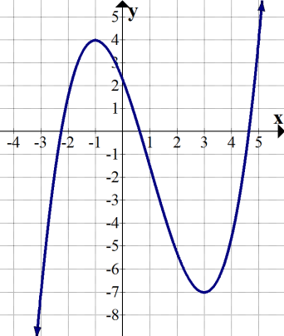  Int. of Increase:  Int. of Decrease: | 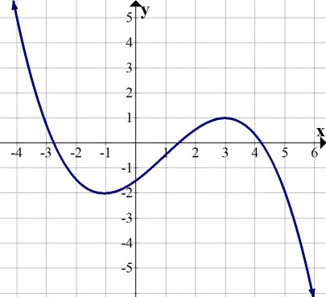  Relative Min:  Relative Max:
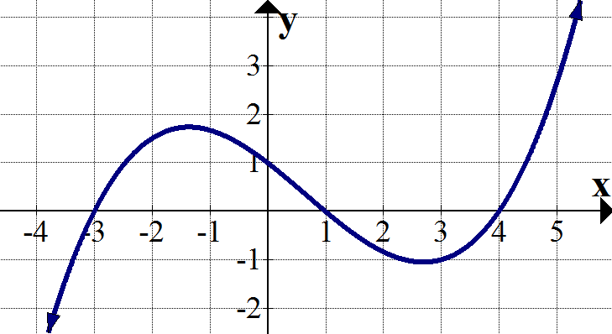  x-intercept(s):  y-Intercept: | 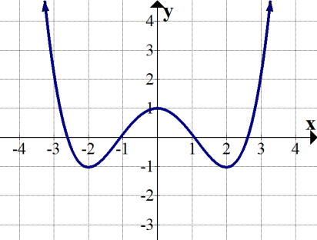  Int. of Increase:  Int. of Decrease: | 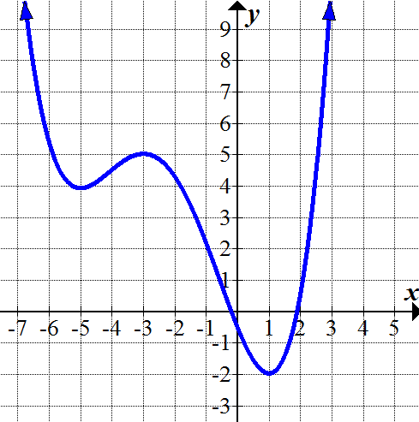  Relative Min:  Relative Max:

Describe the end behavior of the graph of the polynomial function by completing the statements.
- $f\left(x\right)=-{2x}^{5}+3x-1$ | as x → − ∞, f(x) → ______  as x → + ∞, f(x) → ______
- $f\left(x\right)= {6x}^{4}$ | as x → − ∞, f(x) → ______  as x → + ∞, f(x) → ______
- $f\left(x\right)= 2(x+3)(2x-5)(x+7)$ | as x → − ∞, f(x) → ______  as x → + ∞, f(x) → ______

Based on the end behavior, is the degree of the function even or odd? Is the leading coefficient positive or negative?
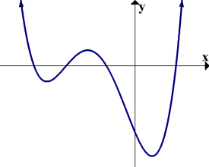  Degree: even / odd  Leading Coeff: positive / negative | 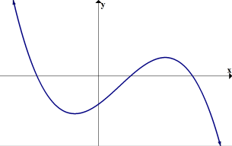  Degree: even / odd  Leading Coeff: positive / negative
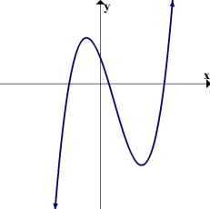  Degree: even / odd  Leading Coeff: positive / negative | 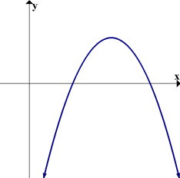  Degree: even / odd  Leading Coeff: positive / negative
Write an equation for the cubic function in standard form.
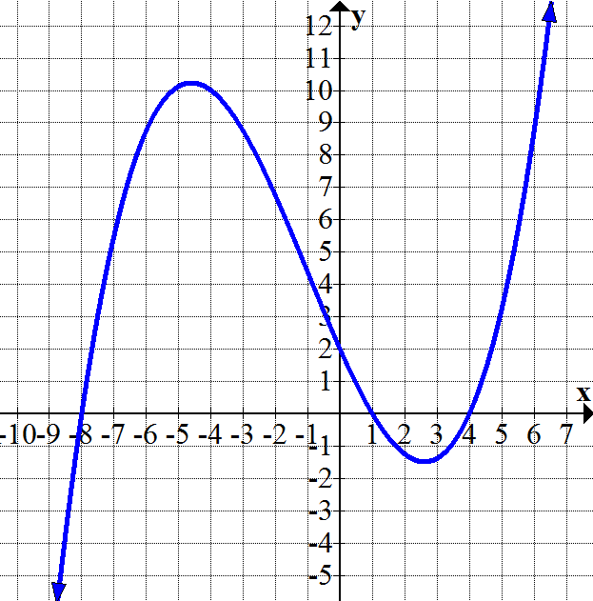 | - x-intercepts: -6, 3, -3; y-intercept: -27
- zeros of the function: 3 (multiplicity 2), 9, and -5  You may give this equation in intercept form. | - zeros 3 and 7 (the zero 7 has multiplicity 2)

Factor each polynomial.
- $x^{2}-12x+32$ | - $x^{4}-12x^{2}+32$
- $x^{3}+13x^{2}+42x$ | - ${2x}^{5}+26x^{3}+84x$
- $125x^{3}-1$ | - $x^{4}-8x^{2}-20$
- $12x^{3}+28x^{2}-3x-7$ | - $2x^{3}-9x^{2}+8x-36$

Solve for x.
- $x^{2}+10x+16=0$ | - $2x^{2}+11x+14=0$ | - $x^{4}-17x^{2}+16=0$
- $x^{3}+2x^{2}-16x-32=0$ | - $2x^{3}+3x^{2}=50x+75$ | - $25x^{2}=1$
The graph a polynomial function $f(x)$ is shown. Match each function transformation to its corresponding graph.
- $f(x)$  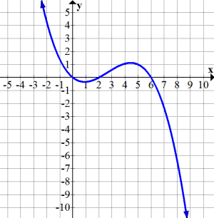  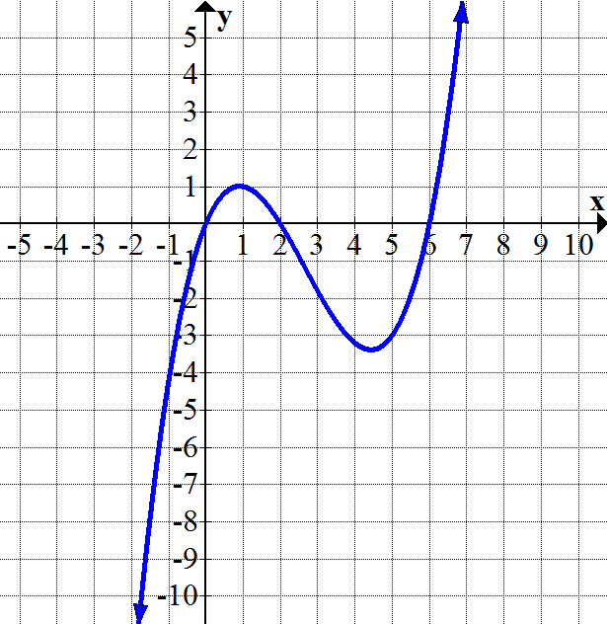 | - $f\left(x\right)+3$  - $f(x+3)$  - $f\left(x\right)-3$ | - $f\left(x-3\right)$  - $3f(x)$ | - $\frac{1}{3}f\left(x\right)$  - $-\frac{1}{3}f\left(x\right)$
 | 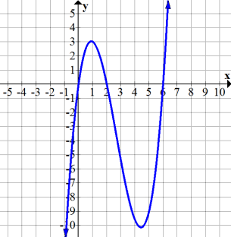  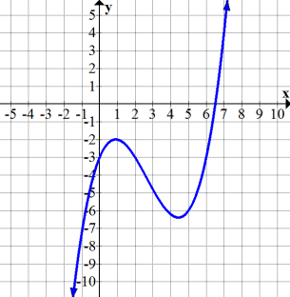 | 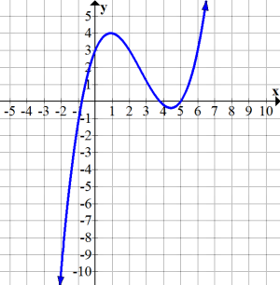  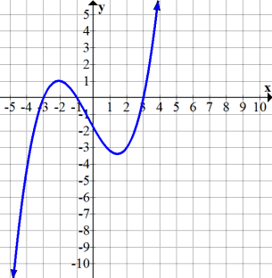 | 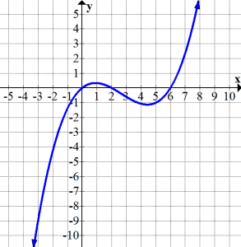  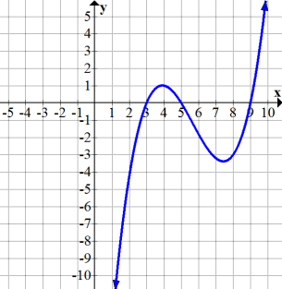
State all zeros of the function (including multiplicities).
- $f\left(x\right)=2(x+3)(x-10)(x+4)$ | - $f\left(x\right)=x\left(x-1\right)\left(2x+7\right){\left(x+3\right)}^{2}$ | - $f\left(x\right)=\left(x-5\right){\left(x+9\right)}^{3}{\left(x-9\right)}^{5}$
State the number of complex roots and the number of real roots for each function shown.
- 4th degree polynomial: 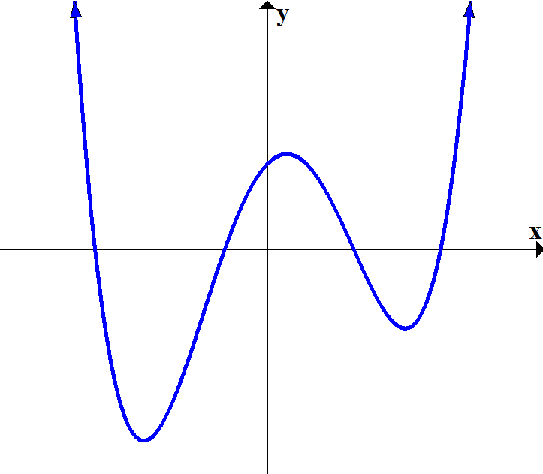  # Complex Roots: ____  # Real Roots: ____  # Non-real Roots: ____ | - 3rd degree polynomial:  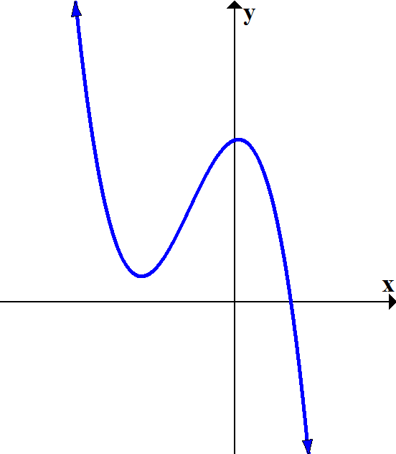  # Complex Roots: ____  # Real Roots: ____  # Non-real Roots: ____ | - 5th degree polynomial:  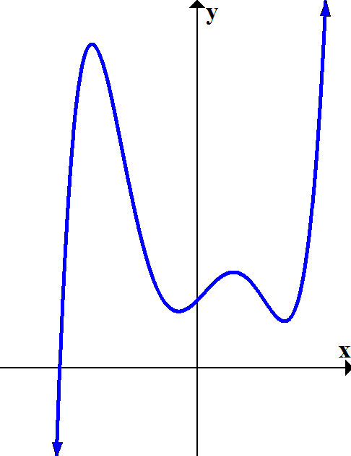  # Complex Roots: ____  # Real Roots: ____  # Non-real Roots: ____ | - 9th degree polynomial:  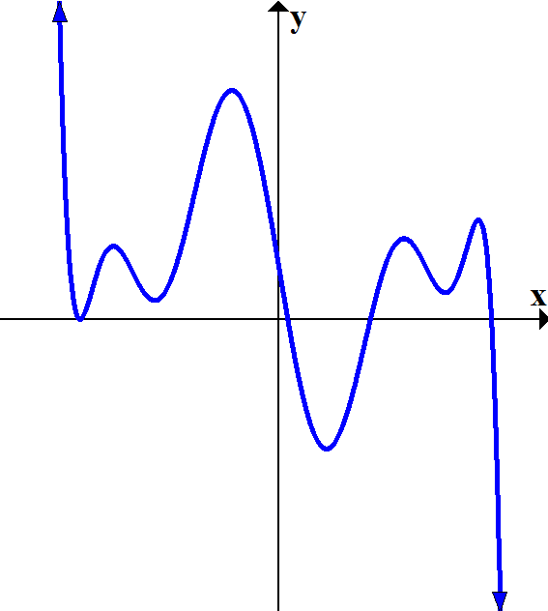  # Complex Roots: ____  # Real Roots: ____  # Non-real Roots: ____
- 4th degree polynomial:  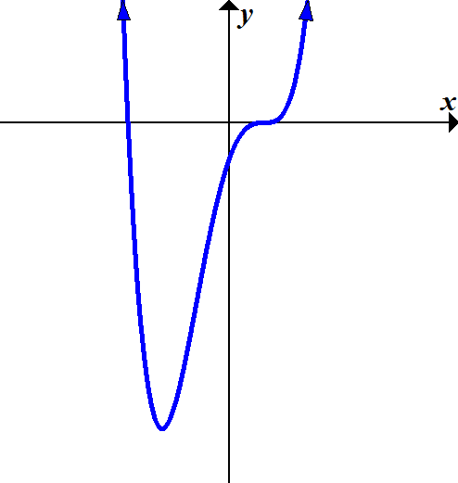  # Complex Roots: ____  # Real Roots: ____  # Non-real Roots: ____ | - 3rd degree polynomial:  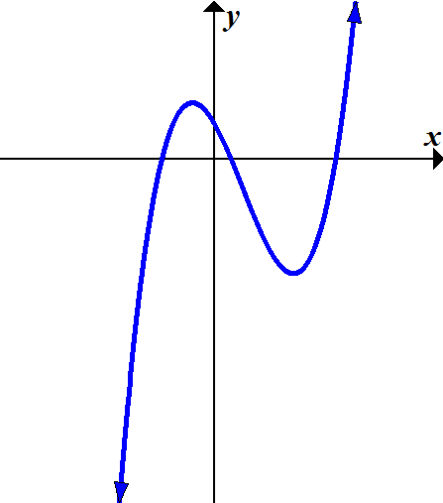  # Complex Roots: ____  # Real Roots: ____  # Non-real Roots: ____ | - 6th degree polynomial:  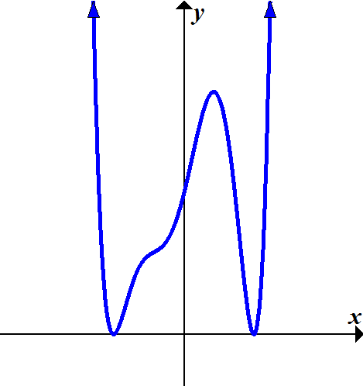  # Complex Roots: ____  # Real Roots: ____  # Non-real Roots: ____ | - 7th degree polynomial: 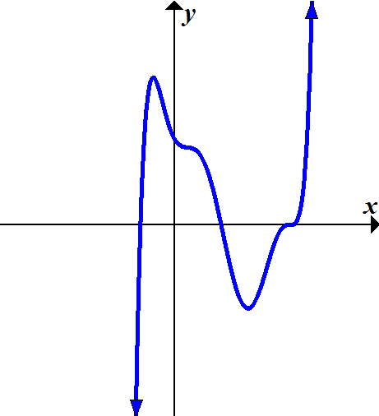  # Complex Roots: ____  # Real Roots: ____  # Non-real Roots: ____
Graph Each Function.
- $f(x)=(x-6)(x-2)(x+3)$  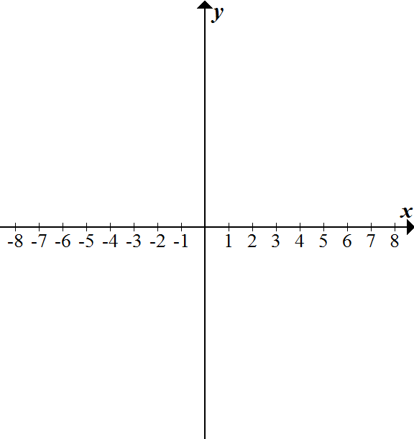 | - $g(x)=x(x+3)(x-4)$ | - $h\left(x\right)=\frac{1}{2}\left(x+4\right){\left(x-1\right)}^{2}$
- $f\left(x\right)=-2{\left(x+3\right)}^{3}$  Answers: 1) D: $(-∞,∞)$ R: $[2,∞)$; 2) Inc: $\left(-∞,-1\right) \left(3,∞\right)$, Dec: $(-1, 3)$; 3) Min: (-1, -2), Max: (3,1); 4) x-int: (-3,0),(1,0),(4,0), y-int: (0,1); 5) Inc: $\left(-2,0\right) (2,∞)$,  Dec: $\left(-∞,-2\right), (0,2)$; 6) Min: (-5,4),(1,-2), Max: (-3,5); 7) $+∞, -∞$; 8) $+∞, +∞$; 9) $-∞, +∞$; 10) even pos; 11) odd neg; 12) odd pos; 13) even neg;  14) $f\left(x\right)=\frac{1}{16}x^{3}+\frac{3}{16}x^{2}-\frac{9}{4}x+2$; 15) $f\left(x\right)=\frac{1}{2}x^{3}+3x^{2}-\frac{9}{2}x-27$; 16) $f\left(x\right)={\left(x-3\right)}^{2}(x-9)(x+5)$; 17) $f\left(x\right)=x^{3}-17x^{2}+91x-147$; 18) $(x-8)(x-4)$; 19) $(x^{2}-8)(x+2)(x-2)$; 20) $x(x+6)(x+7)$; 21) $2x(x^{2}+6)(x^{2}+7)$; 22) $(5x-1)(25x^{2}+5x+1)$; 23) $(x^{2}-10)(x^{2}+2)$; 24) $\left(3x+7\right)\left(2x+1\right)\left(2x-1\right)$; 25) ($2x-9)(x+2i)(x-2i)$; 26) $x=-8, -2$; 27) $x=-2, -\frac{7}{2}$; 28) $x=±4, ±1$; 29) $x=±4, -2$; 30) $x=-\frac{3}{2}, ±5$; 31) $x=±\frac{1}{5}$; 32) top row: c, b, d;  bottom row: g, e, a, f; 33) $-3, 10, -4$; 34) $0, 1, -\frac{7}{2}, -3 (multiplicity 2)$; 35) $5, -9 \left(multiplicity 3\right), 9(multiplicity 5)$; 36) 4, 4, 0; 37) 3, 1, 2; 38) 5, 1, 4; 39) 9, 5, 4; 40) 4, 4, 0; 41) 3, 3, 0; 42) 6, 4, 2; 43) 7, 5, 2; 44-49 (see online) | - $g\left(x\right)=\left(x+4\right)\left(x+1\right)\left(x-3\right)\left(x-5\right)$ | - $h\left(x\right)=-{\left(x+4\right)}^{2}{\left(x-1\right)}^{2}$

