Honors Math II Name_____________________________________________

Graphing/ Quadratic Equations Period______________Date________________________

**Factor the following quadratics.**

1. 2.

3. 4.

5. 6.

**Solve for x by factoring.**

7. 8.

9. 10.

11. 12.

**Multiply the following binomials**.

13. 14.

15. 16.

**Solve for x by using the technique of taking the square root of both sides.**

17. 18.

19. A quadratic equation has an axis of symmetry of $x= -4$. Name the x-intercepts if they are 4 units from the axis of symmetry.

20. A quadratic equation has an axis of symmetry of $x= -7$ and an x-intercept of (-2, 0). What is the other x-intercept?

21. A quadratic equation has an axis of symmetry of $x = 5$ and the x-intercepts are 4 units from the axis of symmetry.

A) Name the 2 possible points for a vertex given that the graph follows the standard rate of change.

B) Name the 2 possible points for a vertex given that the graph has a vertical stretch by a factor of 2.

For questions 22-23, write the quadratic equation that represents the given data in:

A) Vertex Form

B) Intercept Form

C) Standard Form

|  |  |
| --- | --- |
| x | y |
| -4 | 10 |
| -2 | 0 |
| 0 | -6 |
| 2 | -8 |
| 4 | -6 |
| 6 | 0 |
| 8 | 10 |

22.

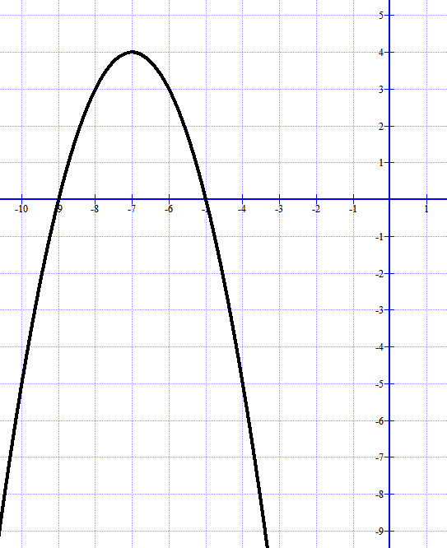

23.

**Questions 24-28: Graph the given quadratic equations and write the equation in Vertex form, Intercept form, and Standard form.**

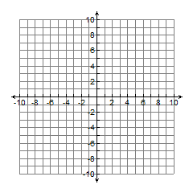24. $f\left(x\right)= -x^{2}-6x-9$

25. $f\left(x\right)=2{\left(x+1\right)}^{2}-18$



26.



27.

28.

29. What are the possible number of zeros that a quadratic equation could have? Make a sketch of each scenario.

30. Explain why the axis of symmetry is useful when writing and graphing quadratic equations.